
EXISTING SD CARD
HOW TO UPDATE CONFIG ON

Please download the config tool from our support site at this location, (you will need to create an account to download the file).
URL: https://support.visiontrack.com
Once downloaded and installed please insert the SD card into your PC.

Click on open
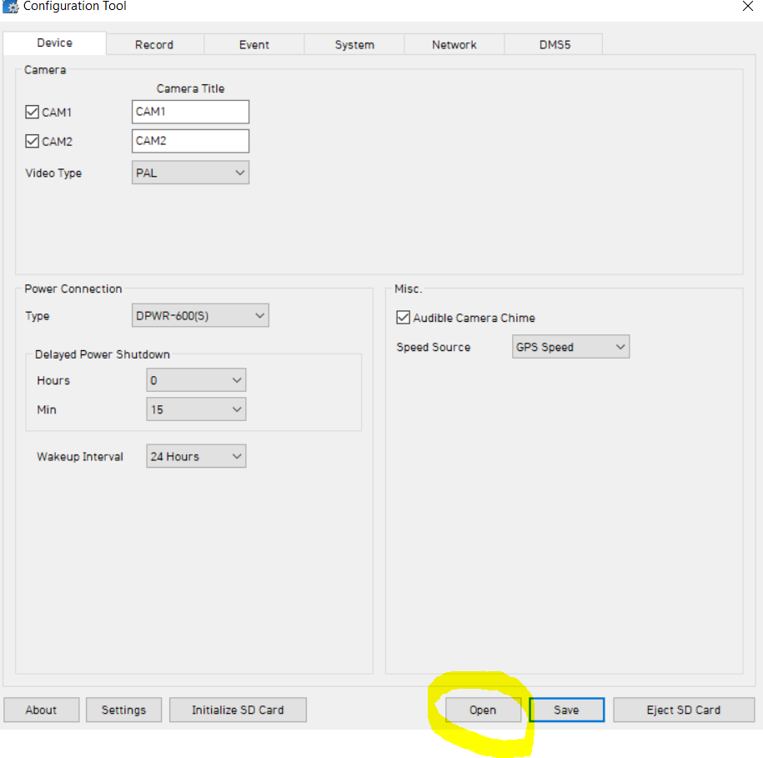

Navigate to SD card FHDRM > Config and select the settings.ini file, select open.
Please note if the file is not there it will be in the Device Folder.

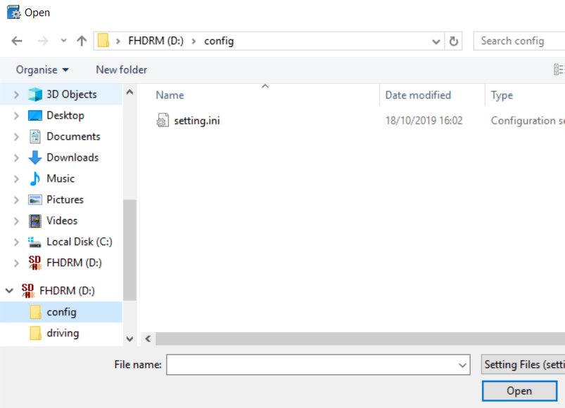

On the device tab please make sure the 2nd camera is ticked.

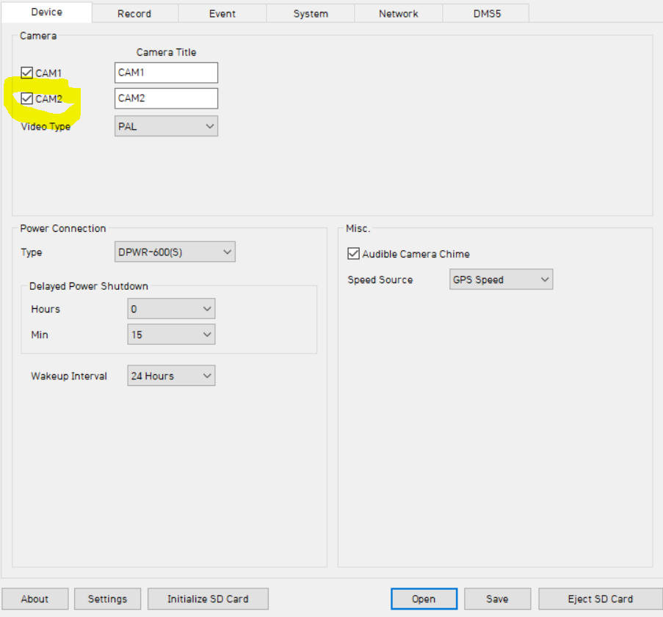

On the network tab please make sure the SIM APN is changed to your own SIM details

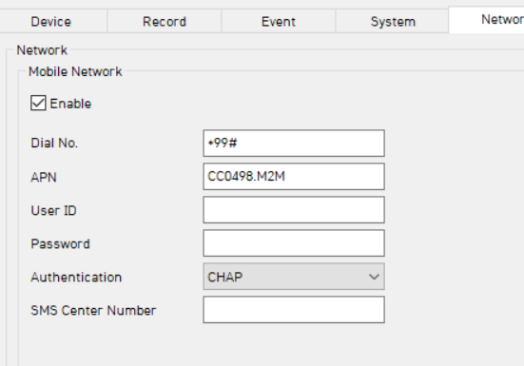

On the last tab please make sure the settings are the same as the below:
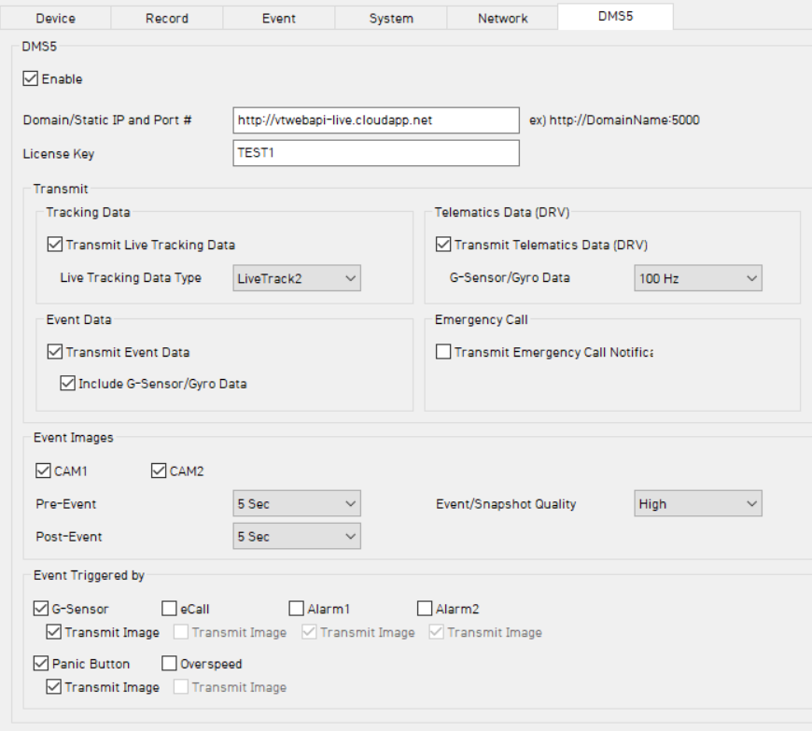

Domain IP:
http://vtwebapi-live.cloudapp.net

Lastly please initialise the SD card, click on initialise and select the SD card

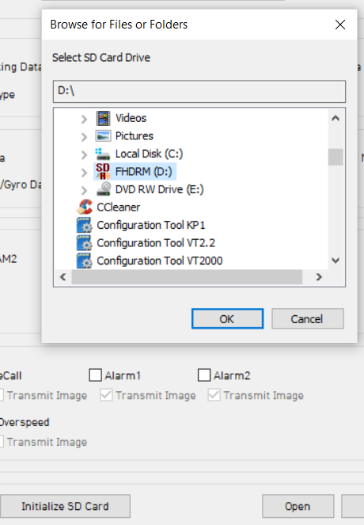

Remove the tick from Keep current config and tick Do not copy config files and click start.

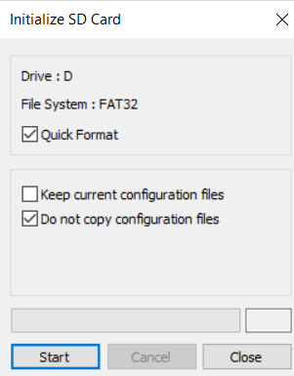

Once complete please click ok to the pop up message

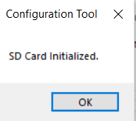

Finally click on save and select the SD card as shown

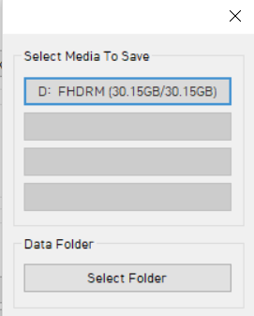

Click ok to the message and then eject the SD card.

