Select the fleet in question
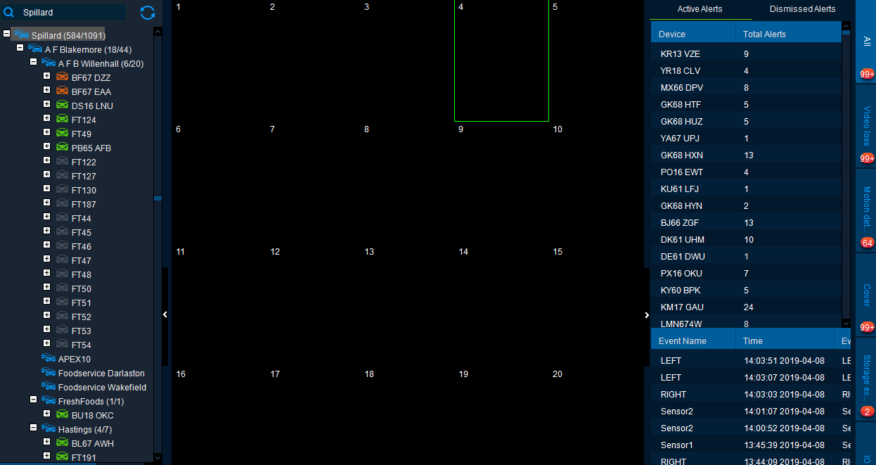
Select the Vehicle/DVR that you need to change the time of, right click and choose settings.

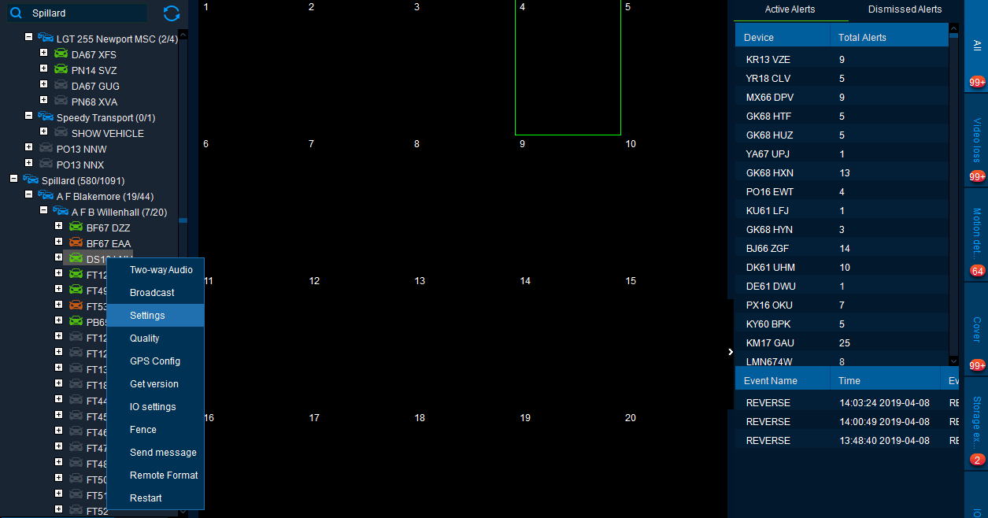
Click confirm at user or password error page to get to the login screen
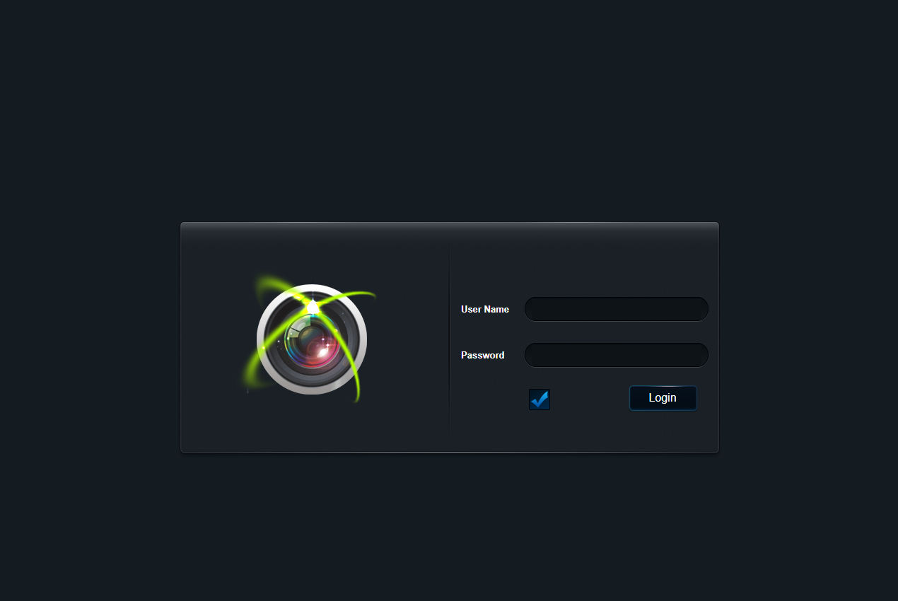
Enter the username and password to log into the DVR. Click the Time Setup menu from the left hand side.
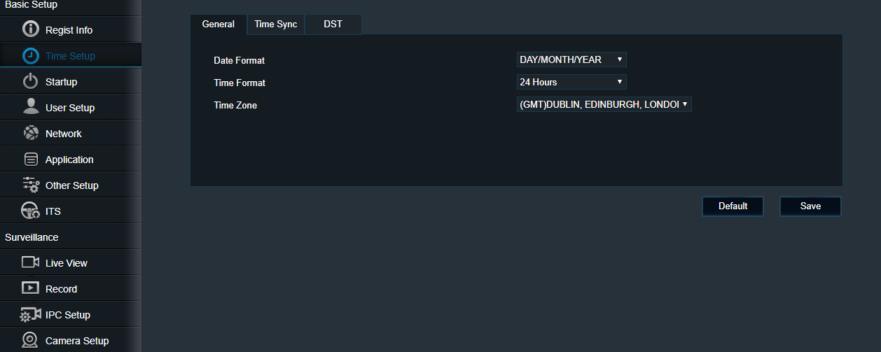
Along the top select DST and change the Start or End time to match the correct BST time change.
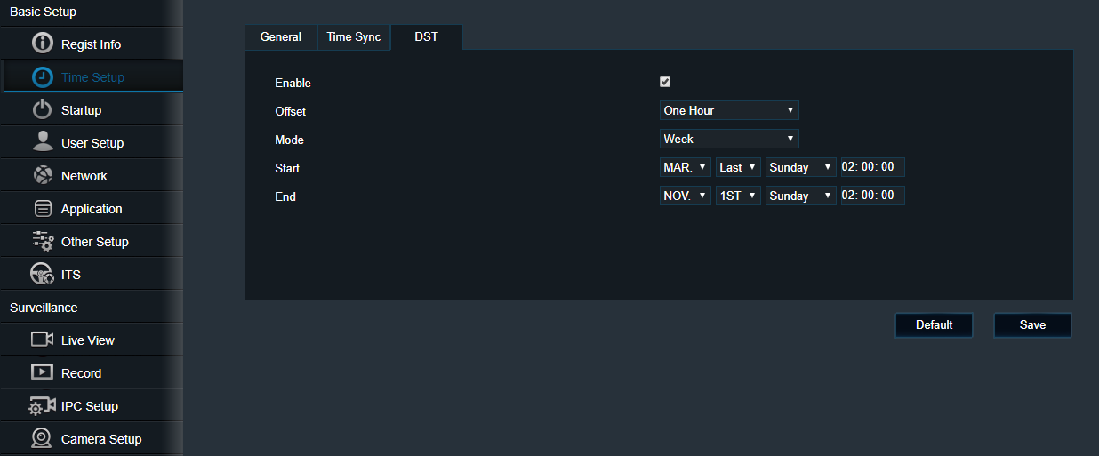
Press Save
Click on Time Sync next to DST, Press Sync with PC and then hit Save.
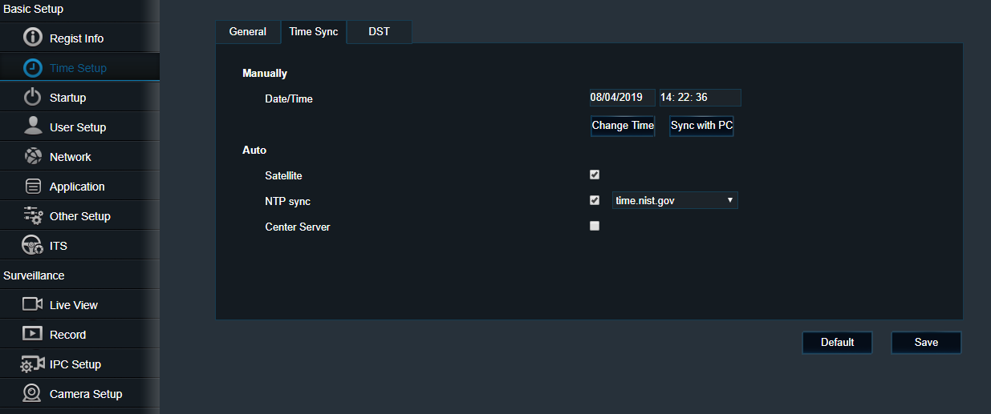
This should complete the process.

