Relocating Devices from One Organisation to Another Organisation
To relocate the devices from one Org to another, as in the case of the 1st 4 devices, you can login to Autonomise/V2 and use the following procedure –

- Locate the device and login to the relevant Organisation.
- Go to System > Vehicle Management.
- Select the vehicle/device and click the 3 dots (Action)
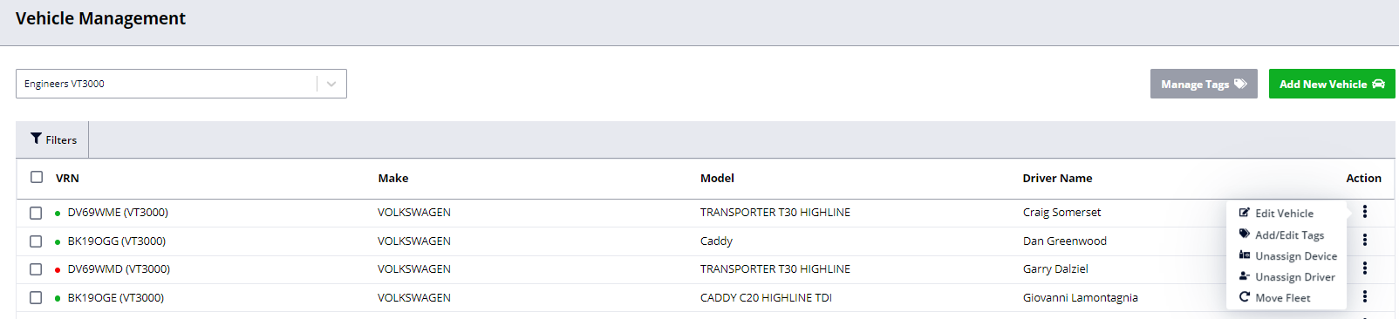
- Click Unassign Device (Note the unit needs to be offline for at least 7 minutes before it can be unassigned)
- Go to System > Platform Management.
- Click Filters, enter the DRID of the device and click Search Devices.
- Select the device and click Actions > Reassign Organisation.
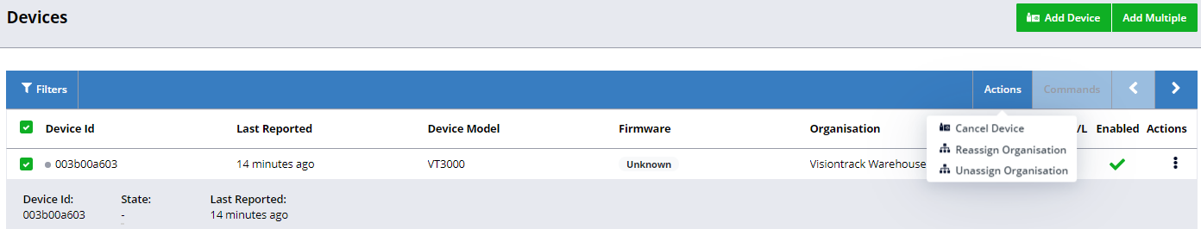
- Enter the correct Organisation and click Assign Organisation.
- Login to this Organisation and go to System > Fleet Management.
- Click/Hold the device in the devices column to the left and drag into the correct fleet on the right-hand side.
NB If this fails try refreshing the browser window (F5).
- Click the fleet to enter Vehicle Management (or go to System > Fleet Management)
- Click Add New Vehicle and enter the vehicle registration OR Chassis Number – if the vehicle is logged with DVLA the details will populate below, else enter the vehicle details and click Add New Vehicle.
- Finally Click/Hold the device on the left and drag onto the new vehicle.

