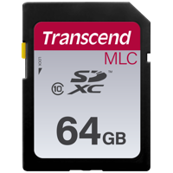
VT1000 64GB SD
SD CARD SUPPORT

STEPS
- Check Current version of PC viewer and VT1000 Firmware
- Download the latest PC viewer 1.0.8.0 from (LINK) Support.visiontrack.com
- Download the latest VT1000 firmware 1.1.4 (LINK) Support.visiontrack.com
- Install PC viewer
- Copy firmware to SD card
- Insert SD card into VT1000 (Firmware upgrade)
- Leave recording for a few minutes then check SD card back in PC viewer to confirm firmware has applied
- Initialise SD card, check and change settings and put back into VT1000

1
- Check current firmware and PC viewer version
- Remove SD card from VT1000
- Insert into PC and open PC viewer software
- Click on
- Select the SD card 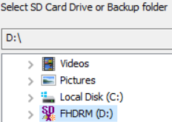

- Select the icon
- This will show you the current PC viewer and Firmware installed on the VT1000 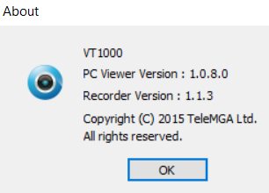

2
- If required, download the latest PC viewer 1.0.8.0 from (LINK) support.visiontrack.com
- Remove the old version from your PC and install the latest version.

3
- If required download the latest VT1000 firmware 1.1.4 (LINK) support.visiontrack.com
- Download the zip file and unzip the folder, move the folder (program) to the root of the VT1000 SD card.

4
- Firmware upgrade
(DO NOT TURN THE POWER OFF DURING THE UPGRADE AS THIS WILL CASUE THE UNIT TO FAIL)
- Put the SD card into the VT1000.
The VT1000 will flash red and blue at the same time for a few seconds and then reboot.
- Once complete the VT1000 will show the blue LED, press the panic button and leave the unit recording for a few minutes.
- Turn off the VT1000 and put the SD card back into the PC viewer.
- Follow step 1 to check the firmware has applied
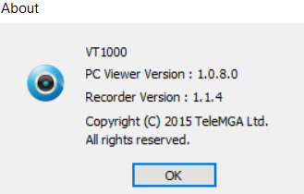

5
- Initialise SD, check and change settings
- Click on

- Click on Init SD Card
- Select ‘Quick Format’ and remove the tick from ‘Backup Configuration File’ and click start
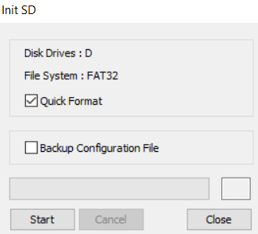
- Once initialised
- Change any settings you need to, PLEASE MAKE SURE THE TICK IS REMOVED FROM SD CARD AUTO FORMAT FEATURE
- Click on ‘OK’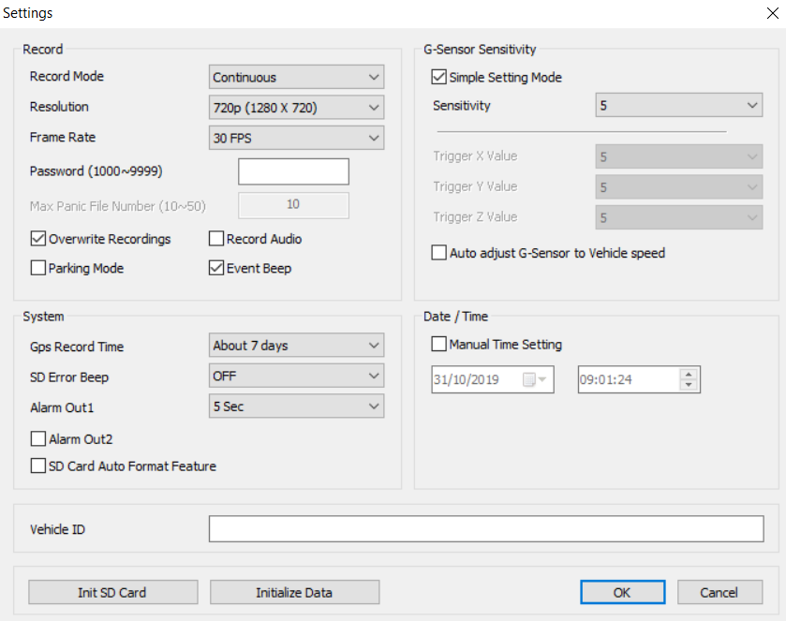
- Select ‘OK’ to save current settings 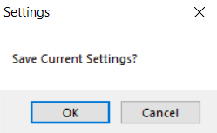
- You can now remove the SD card and place this back into the VT1000.

support.visiontrack.com
Need Support?

